**TASK-10**

Credit Limit

**EXPLANATION:**

The program asks the user to enter his / her

a) Account number (an integer)

b) Balance at the beginning of the month

c) Total of all items charged by this customer this month

d) Total of all credits applied to this customer's account this month

e) Allowed credit limit

After that the program calculates the new balance for the user. Whereas if the new balance exceeds the credit limit the program displays a message

that the credit limit has been exceeded and displays all the above inputs and the new balance also. Whereas the program doesn’t takes a negative values or a character as an input.

**INPUT:**

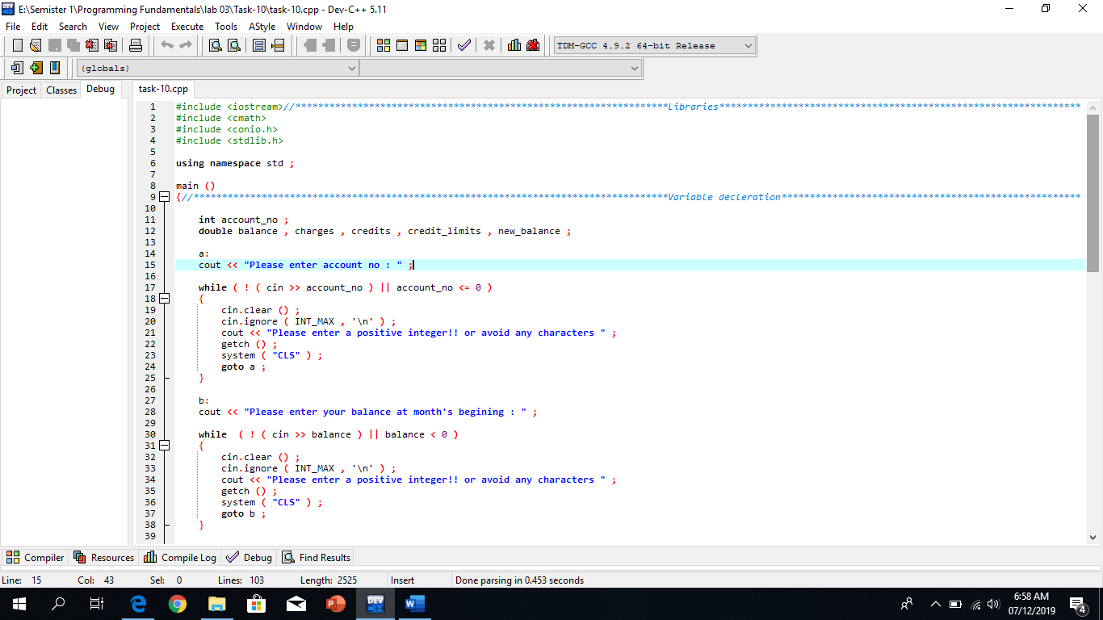

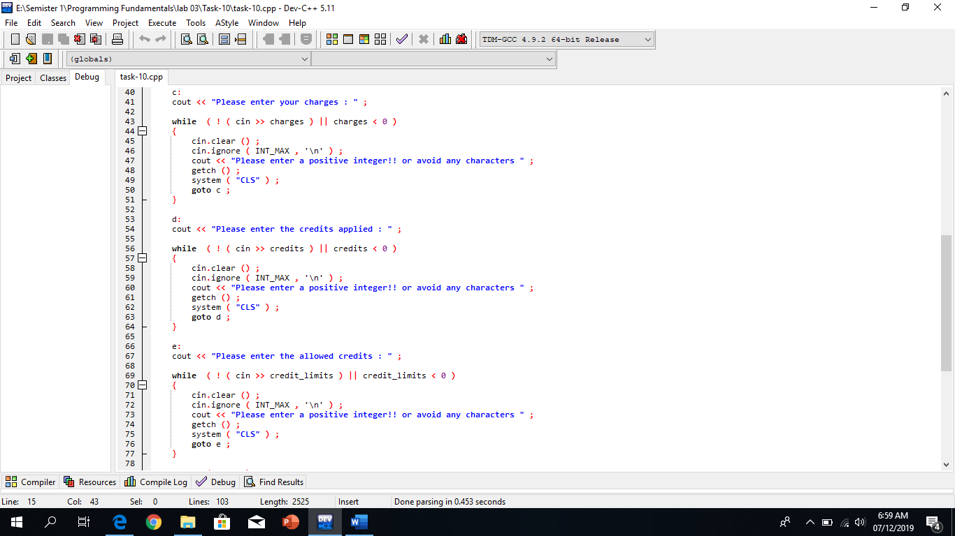

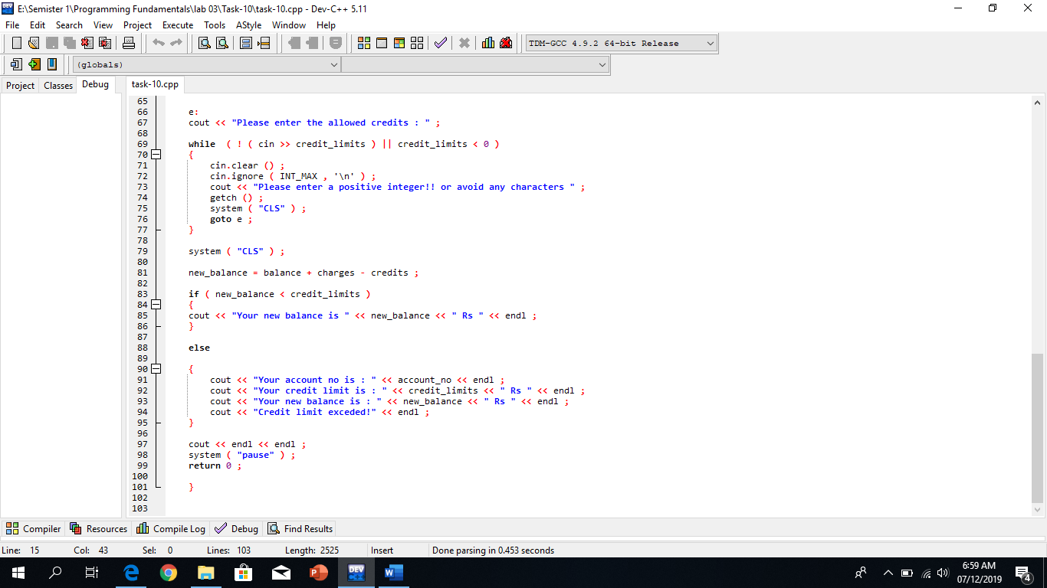

**OUTPUT:**

